- Downloaded the gcloud sdk for windows.

- Initilalized and configured it using command

gcloud init

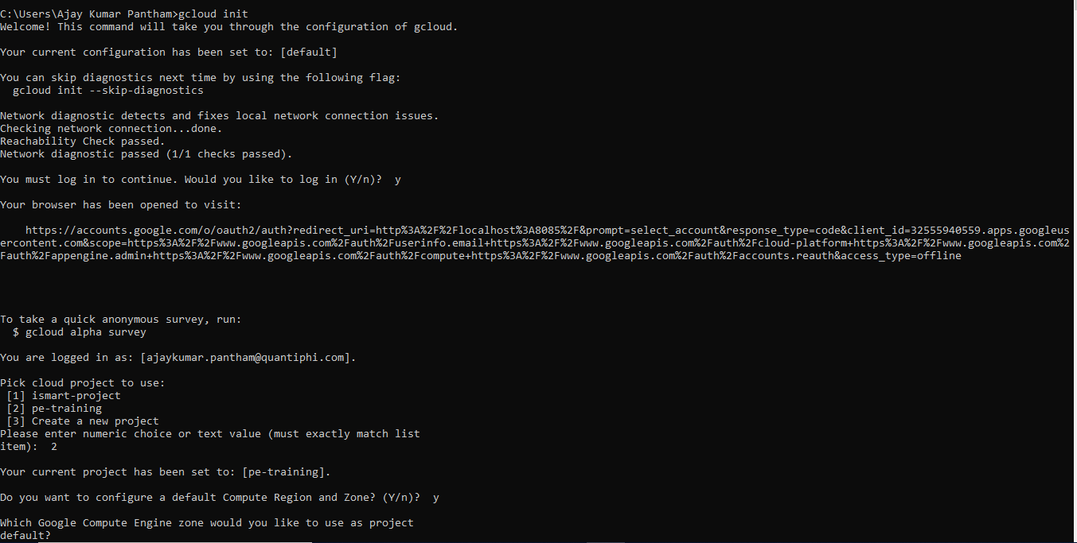

- Checked which of the components are installed

gcloud components list

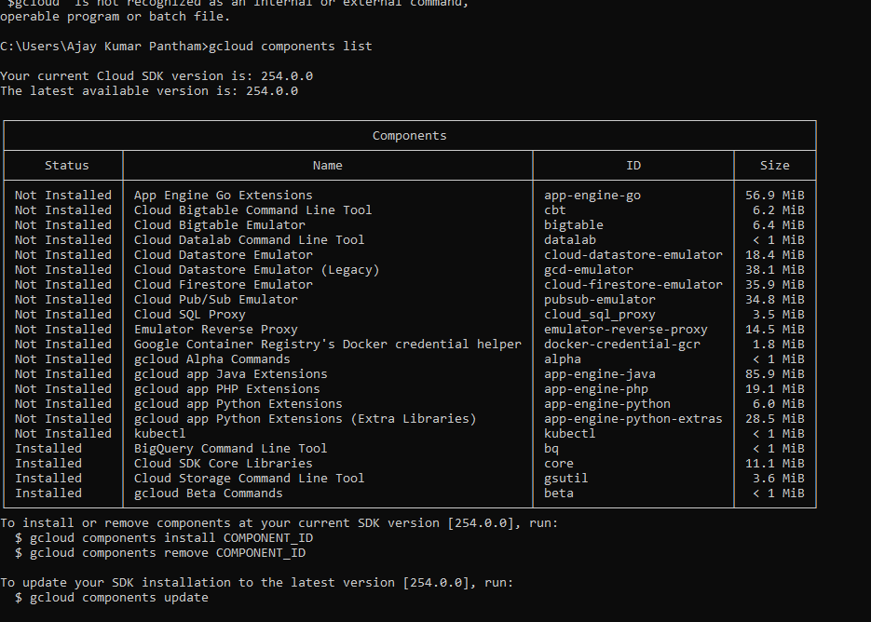

- installed the components kubectl and alpha using command

gcloud components install COMPONENT_ID

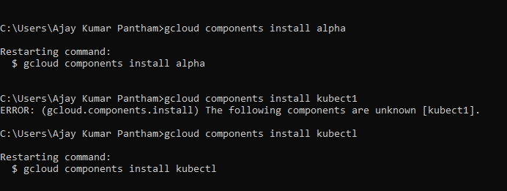

- Checking whether the mentioned components are installed

